

MS Word Training – Session 2: Part 2

Tables, Pictures & Objects
Version: 1.0
February, 2009
Copyright Information:
This document is the sole property of AIG Inc. All rights reserved. No part of this document may be reproduced, stored in a retrieval system, translated, transcribed, or transmitted in any form or by any means, without the prior written permission of AIG Systems Solutions (AIGSS).
Document Information
S.No | Document Title | Base Version No. | Author | Contact Email ID | Date Of Release
1 | MS Word Training – Session 2: Part 2 | 1.0 | Deepika Datta | deepika.datta@aig.com | February, 2009
Revision History
S.No | Version No. | Date Of Release | Author (s) | Affected Section(s) | History of Changes | Approver

Table of Contents
1 Tables 5
1.1 Introduction 5
1.2 Creating tables 5
1.2.1 Create a table using the insert table button 5
1.2.2 Creating a table using the table menu 5
1.2.3 Drawing a table 5
1.3 The tables and borders toolbar 6
1.4 Entering data in a table 6
1.4.1 Aligning text within cells 6
1.5 Moving around a table 6
1.6 Selecting 7
1.6.1 Select using the mouse 7
1.6.2 Select using the keyboard 8
1.7 Modifying table properties 8
1.7.1 Cell margins 8
1.7.2 Modifying cell height and width 9
1.8 Adding and removing rows and columns 10
1.8.1 Adding a row 10
1.8.2 Adding a column 10
1.8.3 Adding multiple rows or columns 10
1.8.4 Deleting a row 11
1.8.5 Deleting a column 11
1.9 Deleting a table 11
1.9.1 Clearing data from a table 11
1.10 Advanced Tables Concepts 11
1.10.1 Convert text to a table or table to text 11
1.10.2 Convert text to a table 11
1.10.3 Convert a table to text 12
1.11 Columns 12
1.12 Entering text 13
1.13 Borders & Shading 13
1.13.1 Borders 13
1.13.2 Adding a border to a paragraph 14
1.13.3 Setting the paragraph border style 14
1.14 Borders and shading dialog box 14
1.14.1 Positioning the border 15
1.15 Page borders 15
1.15.1 Positioning the border 15
2 Inserting Pictures 17
2.1 Introduction 17
2.2 Inserting clip art 17
2.3 Using the Clip Organizer 17
2.3.1 Copying a clip art image 17
2.4 Insert a picture from a file 18
2.5 Screen captures 18
2.6 Picture toolbar 19
2.7 Borders 19
2.8 Word Art 19
2.9 Inserting WordArt 19
2.9.1 WordArt toolbar 20
3 Inserting Objects 21
3.1 Working with Objects 21
3.2 Selecting objects 21
3.3 Stacking objects 21
3.4 Rotating or flipping objects 21
3.5 Grouping and ungrouping objects 22
3.5.1 Grouping objects 22
3.5.2 Ungrouping objects 22
3.5.3 Regroup objects 22
3.6 Align and arrange objects 22
3.6.1 Aligning objects with other objects 22
3.6.2 Align objects in relation to the canvas 23
3.6.3 Align objects in relation to the page 23
3.6.4 Arrange drawing objects equal distances from each other 23

Tables

Introduction
The tables feature can be used to organize information and create interesting page layouts. It can be used as an alternative to working with columns or tabs to produce similar effects more easily. A table consists of vertical columns and horizontal rows.

Creating tables
You can create a table using the Insert Table button on the toolbar, or via the Table menu.

Create a table using the insert table button
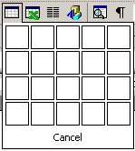
- Position the insertion point where the table is to be placed.
Insert Table button

- Click on the Insert Table button on the Standard toolbar.
A grid appears below the button.
- Click and drag over the grid to select the number of columns and rows required in your table. As the area specified expands so too does the grid.
- Release the mouse button when the desired table has been selected.
A table is created to your specification. The insertion point is flashing in the top left-hand cell awaiting data entry. Borders have been applied automatically and these define the individual rows, columns and cells of the table (as shown below).
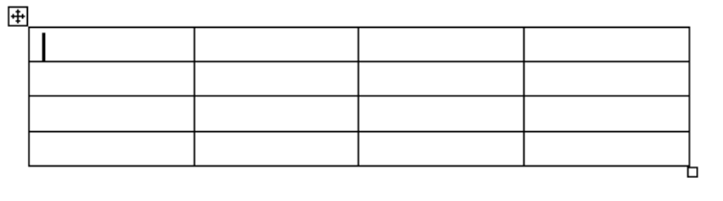
The handle in the top-left corner of the table allows you to select and move the entire table easily. The handle at the bottom-right of the table allows you to resize the table.
Table move handle
Table resize handle

Creating a table using the table menu
- From the Table menu click Insert and then Table.
- In the Insert Table dialog box which appears, enter the number of rows and columns you require.
You can choose to have fixed column widths or to adjust automatically the width of the columns to accommodate the contents.
- Once you have made your selections, click OK..

Drawing a table
If you need to create a complex table you can draw the table yourself using the tools in the Table and Borders toolbar. To display the Tables and Borders toolbar, click this button on the Standard toolbar.
To draw a table:
- Click the Table and Borders button on the toolbar to display the Table and Borders toolbar.
- Click where you want to create the table.
- On the Tables and Borders toolbar, click Draw Table button (it may already be selected when you open the toolbar).
- 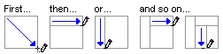The pointer changes to a pencil.
- To define the outer table boundaries, draw a rectangle. Then draw the column and row lines inside the rectangle.
- To erase a line or block of lines, click the Eraser button, and then drag over the line you want to erase.
Note:
If you want your document text to flow around your table, hold down the Ctrl key as you draw your table.

The tables and borders toolbar
The Tables and Borders toolbar provides a number of options for modifying tables:
Draw Table
Eraser
Line Style
Line Weight
Border Color
Outside Border
Shading
Insert Table
Split Cells
Distribute Rows
Distribute Columns
Auto-Format
Text Direction
Sort
AutoSum
Merge Cells
Align-ment

This toolbar should appear automatically when your cursor is positioned in a table. To turn it on manually, right-click on any toolbar, and select Tables and Borders from the shortcut menu.

Entering data in a table
You can enter text into each cell in your table and it can run to several lines within one cell if necessary.
To enter data in a table:
- Position the cursor in the cell where you want the information and key in your data.
- Press Enter to start a new line within the same cell, or press Tab to move to the next cell.

Aligning text within cells
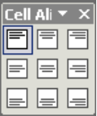
You can choose horizontal, centre, left or right alignment options for text within table cells using the alignment buttons on the Formatting toolbar.
You can choose both horizontal and vertical alignment options from the Alignment button  on the Tables and Borders toolbar. The following cell alignment options are available:

Moving around a table
The table below outlines some techniques for moving in a table:
To | Press
Move to the next cell | Tab (If the insertion point is in the last cell of a table, pressing Tab adds a new row.)
Move to the preceding cell | Shift+Tab
Move to the preceding or next row | ↑ or ↓
Move to the first cell in the row | Alt+Home
Move to the last cell in the row | Alt+End
Move to the first cell in the column | Alt+Page Up
Move to the last cell in the column | Alt+Page Down
Start a new paragraph | Enter
Add a new row at the bottom of the table | Tab at the end of the last row
Add text before a table at the beginning of a document | Enter at the beginning of the first cell

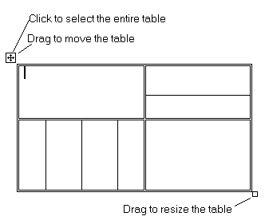Selecting
When your pointer is inside a table, a button appears to the top left of the table. You can click this button to select the entire table. You can also use this button to drag the table to another position in your document.
Another button appears to the bottom right of the table. Use this button to re-size your table.

Select using the mouse
The table below outlines some methods for selecting table components:
To | Do this
Select a cell | Click the left edge of the cell.
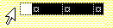Select a row | Click to the left of the row.
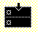Select a column | Click the column's top gridline or border.
Select multiple cells, rows, or columns | Drag across the cell, row, or column; or select a single cell, row, or column, and then hold down Shift while you click another cell, row, or column.
Select the entire table | Click the button to the top left of the table.

Select using the keyboard
To | Press
Select the next cell's contents | Tab
Select the preceding cell's contents | Shift+Tab
Extend a selection to adjacent cells | Hold down Shift and press an arrow key repeatedly.
Select a column | Click in the column's top or bottom cell. Hold down Shift and press ↑ or ↓ repeatedly.
Extend a selection (or block) | Ctrl+Shift+F8 Use the arrow keys to move through the cells you want to select. Press Esc to cancel selection mode
Reduce the selection size | Shift+F8 (cancels the selection, selection mode still on)
Select an entire table | Alt+5 (On the Number Pad with the Num Lock switched off)
Note:
You can also select rows, columns, or the entire table by clicking in the table and then using the Select commands on the Table menu.

Modifying table properties
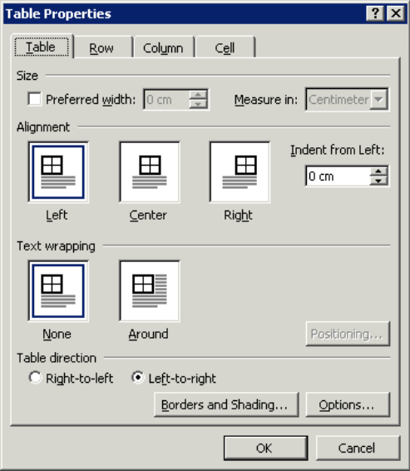
The Table Properties dialog box can be used to control the position of a table within a page, and the height and width of rows, columns and individual cells.
- To access the dialog box choose Table | Table Properties – the options available to you depend on which part of the table was selected.
- If you wish to work on a single cell, simply click in that cell.
- To work on a column or group of columns, select the column(s) first.
- To work on a row or group of rows, select the row(s) first.
- Then choose the Row, Column or Cell tabs as appropriate.

Cell margins
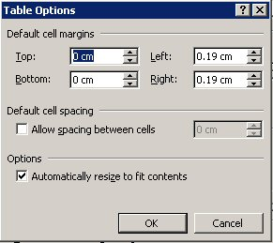
To set a distance between the borders of the cells and the text, you can set cell margins.
To set cell margins:
- From the Table menu, select Table Properties.
- Select the Table tab.
- Click the Options button.
- Set the margins as required and click OK.
- Click OK again to close the dialog box.

Insert space between cells
To set a distance between cells:
- From the Table menu, select Table Properties.
- Select the Table tab.
- Click the Options button.
- Click into the Allow spacing between cells checkbox.
- Key in a distance in the box on the right.
- Click OK.
- Click OK again to close the dialog box.

Modifying cell height and width

Changing column width
You can change column width using the Table Properties dialog box as outlined above, or you can use the mouse method to change the width:
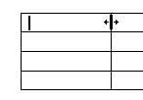
- Position the insertion point against the right-edge border of a column that you want to change until it changes into a double-headed arrow.
Mouse pointer as double-headed arrow

- Click and drag until the column is the desired width and release it.
- A dotted line will indicate the new column width as you drag.
- All cells within the selected column will adopt the new width.

Changing cell width
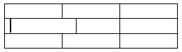
- Select the cell that you want to change.
- Click and drag the edge until the cell is the desired width and release it.
- Only the selected cell will be resized.

Changing row height
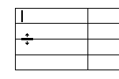
You can change row height using the Table Properties dialog box as outlined above, or you can use the mouse method to change the height:
Mouse pointer as double-headed arrow

- Position the insertion point against the bottom border of the row that you wish to change until it changes into a double-headed arrow.
- Click and drag the border until the row is the desired height and release it.
- A dotted line will indicate the new row height as you drag.
- All cells within the selected row will adopt the new height.

Adding and removing rows and columns

Adding a row
- Position your insertion point in a row within your table, or to add a row at the bottom of a table, position the insertion point just below the table.
- On the Table menu click Insert Rows (or use the Insert Rows button on the toolbar ).
- A new blank row appears above the selected row in the table. The new row is the same height as the previously selected row.

Adding a new row at the end of a table
To add an extra row at the end of a table, position the insertion point in the last cell and press the Tab key.

Adding a column
- Position the pointer above the top edge of a column, or to add a column to the end of a table, position the insertion point above the table immediately to the right.
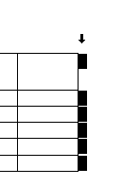
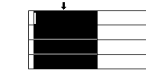
- When the insertion point changes into a down-arrow shape, click to select the column.
Last column in the table

Selected column

Text box

Text box

WebCT for Designers

ox

WebCT for Designers

ox

box

Mouse pointer as down-arrow

Figure 8

Insert an executive summary or abstract at the top of the document

Highlight key points

Figure 9

Hide everything but the summary without leaving the original document

Use the AutoSummarize function to "create a new document" based on 20% of the original.
Print off the summary and score it The AutoSummarize dialog box

fluency of summary.
Create your own version, improving on the auto-summary without increasing the word length.

the [Ctrl] key while selecting the files.

Tip:

d down the [Ctrl] key while selecting the files.

Tip:

Figure 8

Insert an executive summary or abstract at the top of the document

Highlight key points

Figure 9

Hide everything but the summary without leaving the original document

Use the AutoSummarize function to "create a new document" based on 20% of the original.
Print off the summary and score it The AutoSummarize dialog box

fluency of summary.
Create your own version, improving on the auto-summary without increasing the word length.

the [Ctrl] key while selecting the files.

Tip:

d down the [Ctrl] key while selecting the files.

- From the Table menu click on Insert Columns (or use the Insert Columns button on the toolbar). 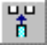
A new blank column appears to the left of the selected column in the table. The new column is the same width as the selected column.
* The Insert Rows/ Columns menu/ buttons are only available if the insertion point is within a table and a row/column has been selected.

Adding multiple rows or columns
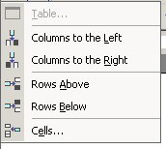
You can add more than one row or column at a time to your table.
To add several rows or columns:
- Select the number of rows or columns you want to insert, starting with the row above or below where you want the new ones or to the left or right of the new columns.
- From the Table menu, select Insert.
- From the sub-menu, select the appropriate option.
- The number of rows or columns that you had selected will be inserted.

Deleting a row
- Select a row by clicking in the selection bar (this is the area immediately to the left of the row).
- From the Table menu click Delete Rows.

Deleting a column
- Position the insertion point above the top edge of a column.
- When it changes into a down-arrow shape, click to select the column.
- On the Table menu click Delete Columns.

Deleting a table
- Position the insertion point within a table.
- On the Table menu click Select Table.
- On the Edit menu click Cut/ Select the table and press Shift+Delete.

Clearing data from a table
Select the table and press the Delete key. The data will be deleted, but the structure of the table will remain.

Advanced Tables Concepts

Convert text to a table or table to text

Convert text to a table
When you convert text to a table, you separate text with a comma, tab, or other separator character to indicate where a new column should begin. Use a paragraph mark to begin a new row.
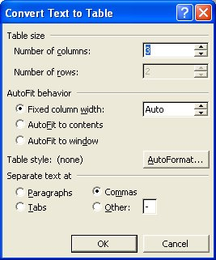
- Indicate where you want to divide text into columns by inserting the separator characters you want.
- For example, in a list with two words on a line, insert a comma or a tab after the first word to create a two-column table.
- Select the text you want to convert.
- On the Table menu, point to Convert, and then click Text to Table.
- Under Separate text at, click the option for the separator character you have used.
- Select any other options you want.
- Click OK.
Example — Before:
Title, Name, Phone
Ms, Sue Jones, 0206 333 3333
Mr, Jack Smith, 01983 666 6666
Miss, Jayne Suzupak, 01702 777 5555

After:

Title | Name | Phone
Ms | Sue Jones | 0206 333 3333
Mr | Jack Smith | 01983 666 6666
Miss | Jayne Suzupak | 01702 777 5555

Convert a table to text
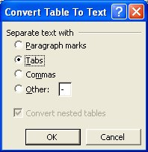
- Select the rows or table that you want to convert to paragraphs.
- On the Table menu, point to Convert, and then click Table to Text
- Under Separate text with, click the option for the separator character you want to use in place of the column boundaries.
Rows are separated with paragraph marks.
- Click OK.

Columns
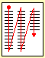You can divide all or part of your document vertically into sections so that it is laid out in newspaper style in columns. Text in newspaper columns flows from the bottom of one column to the top of the next.
Word will automatically section off the area where the columns are active, so, if you are in Normal view, you will see section breaks appear above and below the column area.
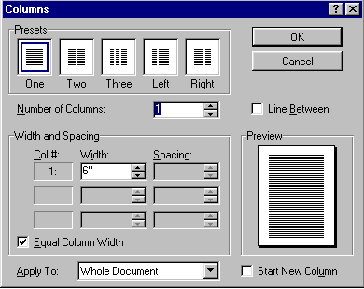To set up newspaper columns:
- From the Format menu, select Columns.
- In the Columns dialog box, the number of columns may be entered in to the Number of Columns box, or one of the Presets may be chosen.
- Adjust the space between columns if necessary (the default is 0.5 inches).
By default the columns are equal width (unless either the Left or Right Preset option is selected). To set columns of unequal width, deselect the Equal Column Width check box.
- Specify the width for each column and the amount of space required between them in the Width and Spacing boxes.
- In the Apply To drop-down list there is an option to apply the columns to the Whole Document or from This Point Forward, or if some text has been selected, columns can be applied to Selected Text.
- When you have completed your set up, click OK to activate the column settings.
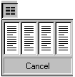Alternatively,
If you want up to four evenly spaced columns, you can click on the Columns icon on the toolbar and drag the mouse to select the required number of columns. This option uses all the defaults.

Entering text
Once your document has been set up with a columnar layout, you can enter text in the usual way. Make sure you are in Print Layout view; otherwise you will not see a true representation of how your document will print out.

Borders & Shading
Borders and shading can be applied to many different objects in Word. You can add borders and shading to text boxes, tables, border paragraph edges, or even an entire page in a document.

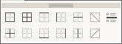
Borders
Clicking on the drop-down arrow next to the Borders button on the Formatting toolbar displays the border options.

The buttons on the palette perform the following functions:
Applies or removes an outside border
Applies all borders
Applies or removes a top border
Applies or removes a left border
Applies or removes inside horizontal borders
Applies or removes a descending diagonal line through a cell
Applies or removes an inside border
Removes all borders
Applies or removes a bottom border
Applies or removes a right border
Applies or removes inside vertical borders
Applies or removes an ascending diagonal line through a cell
Applies or removes a horizontal line.
The Borders button changes to reflect the last border style you applied. Just click on the button to re-apply the same border style again.

Adding a border to a paragraph
Select the paragraph and click on any combination of border tools to determine which edges of the paragraph are bordered.

Setting the paragraph border style
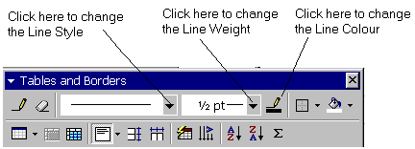To set the style or weight of a border you need to display the Tables and Borders toolbar. Right-click on any toolbar and select Tables and Borders,
or
click on the Tables and Borders button on the Standard toolbar.
- Click in the paragraph which needs a border or select the paragraphs if more than one paragraph is to have a border.
- Click the drop-down arrow in the Line Style box on the Table and Borders toolbar and select a suitable line style.
Note:
Do not look for a Border box. Borders count as line styles.
- Click on the drop-down arrow in the Line Weight box and select a suitable weight for your border.
- To change the colour of the border, click on the Border Color button and select a colour.
- Click on the drop-down arrow next to the Border button to specify which edges of the paragraph you want the line style and weight to apply to.

Borders and shading dialog box
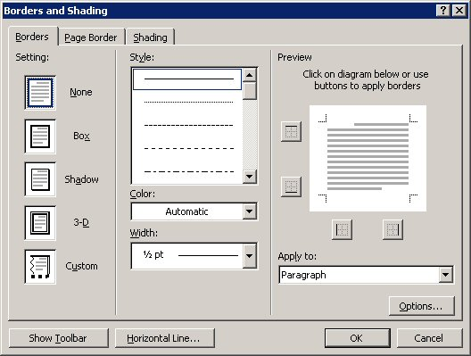
Borders can be added using the Borders and Shading dialog box available by selecting Borders and Shading from the Format menu. Applying borders in this way gives you more line style, shading etc. options.
To apply borders using the Borders and Shading dialog box:
- Select the paragraph or text you want to place a border around.
- Choose Borders and Shading from the Format menu.
- Click on the Borders tab.
- Choose the required border from the Setting area on the left.
- Set the style, colour and width.
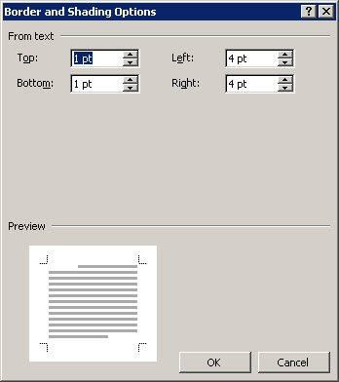
- Select which borders you want to set and check the preview on the right.
- In the Apply to box, select either Text or Paragraph.

Positioning the border
- To set a distance between the border and the text, click the Options button in the Borders and Shading dialog box.
- The default is 1pt from the top and bottom borders, and 4 pt from the left and right borders.
- Make any necessary changes, check the result in the Preview pane, and then click OK.
- Click OK again to close the Borders and Shading dialog box.

Page borders
You can add a border to a page, and then format that border as required. You can give your border rounded edges, apply a shadow, and change the colour or line style in the same way as any other border.
To apply a page border:
- Place the cursor on the page for which you want to create a border.
- 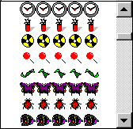Choose Borders and Shading on the Format menu.
- Click on the Page Border tab.
- Choose the required border from the Setting area on the left.
- Set the style colour and width.
- To select a picture border, click on the drop-down arrow next to the Art box. Click on a picture border to select it.
- Select which borders you want to set and check the preview on the right.
- In the Apply to box, select either Whole document, This section, This section – first page only, or This section – All except first page.

Positioning the border
To set a distance from the edge of the page to the border, or between the border and the text, click the Options button in the Borders and Shading dialog box.
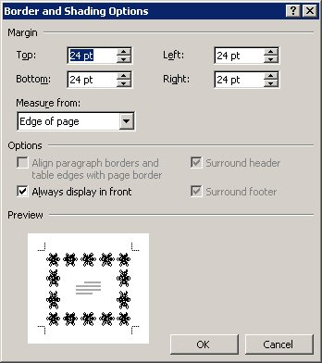
To set a distance from the edge of the paper:
- In the Measure from box, select Edge of page.
The default is 24pt from the top, bottom, left and right edges.
Make any necessary changes, check the result in the Preview pane, and then click OK.
- To set a distance from the text to the border:
- In the Measure from box, select Text.
The default is 1pt from the top and bottom borders, and 4pt from the left and right borders.
Make any necessary changes and check the result in the Preview pane.
- Select any of the other options you require, e.g., whether or not to place the header and footer inside the border.
- Click OK.
- Click OK again to close the Borders and Shading dialog box.

Inserting Pictures

Introduction
Using the Microsoft Clip Art Gallery, you can insert professionally designed images. There are hundreds to choose from, including maps, people, business images, animals, scenic backgrounds and symbols.
Once you insert a clip art image in your document, you can move it and resize it. You can insert many popular graphic file formats into your document.

Inserting clip art
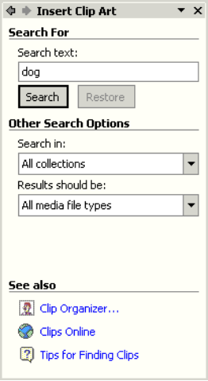
- Click where you want to insert the graphic.
- From the Insert menu, point to Picture, and then select Clip Art to display the Insert Clip Art task pane.
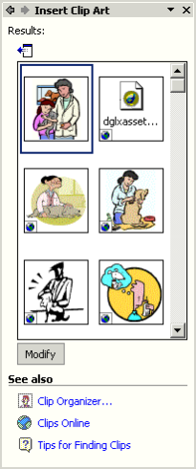
- Key in a word to describe the image you want into the Search text box.
- You can specify where you want to search in the Other Search Options area of the task pane.
- You can also specify what types of files you are looking for, e.g. clip art, photographs etc.
- Click the Search button to start the search.
- The task pane will now display suitable clip art images.
- Click on your chosen image to insert it on your page.
To change your search specification:
In Word 2003, key in your new search criteria in the Search text box at the top of the Task bar.
In Word 2002, click on the Modify button to display the Search option pane.

Using the Clip Organizer
- To display all available clip art images, click on Clip Organizer at the bottom of the Clip Art task pane.
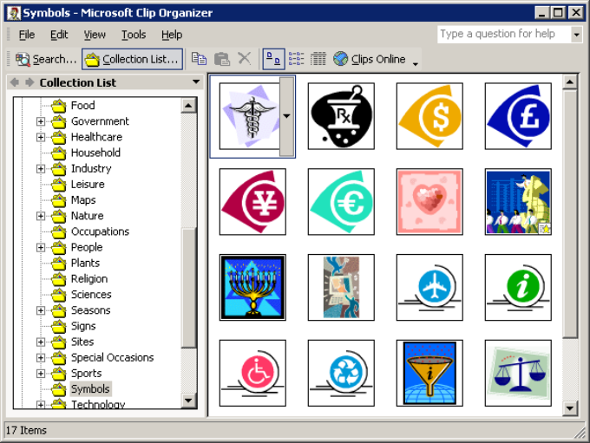
- To display Microsoft clip art images:
- Click on the + sign next to the Office Collections option in the Collection List on the left of the dialog box.
- You will be offered a list of categories.
Click on the relevant category to display its images on the right of the dialog box.
- Click on the image you want to insert into your document.

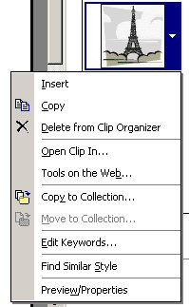
Copying a clip art image
If you find a clip that you would like to use again, you can copy it to your Favourites folder.
To copy a clip art image:
- When you hover the mouse over an image in the Insert Clip Art task pane, a menu bar appears. Click on the bar to display the menu.
- Select Copy to Collection.
- Select the folder you want to save your image in, e.g. the Favorites folder, and clip OK.
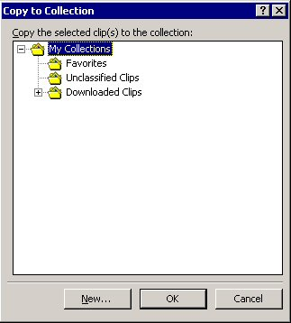

Insert a picture from a file
Provided you have loaded the appropriate filters, Word can import graphics from many other applications or pictures you have scanned in yourself.
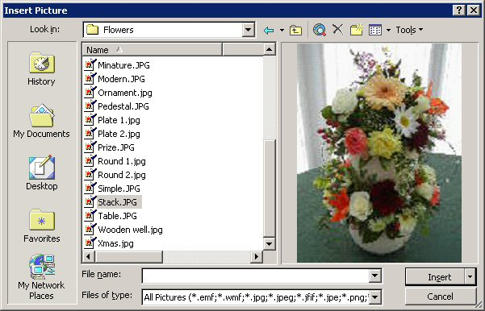
To insert a picture from a file:
Views button
- From the Insert menu, point to Picture, and then select From File.
- Locate the folder containing the graphic you want to insert in the Look in box.
- Select the picture from the list on the left. The picture will be shown on the right.
- Click Insert to insert the picture and close the dialog box.

If your picture is not shown in the right of the Insert Picture dialog box, change the display option by clicking on the Views button on the toolbar and selecting Preview.

Screen captures
There may be times when you would like to capture a picture of something on your computer screen, and display it in a document, or, perhaps, just print it out. This is particularly useful if you are producing notes on how to do something on a computer.
The Print Screen key (normally to the top right of your keyboard) enables you to do this.
- To paste an image of your screen into a document or image-editing application:
- Display the image you wish to capture on the screen. Use zoom options to size the image if necessary.
It is possible to crop (cut off) sections of the image that are not required after you have pasted it into a document or image-editing application.
- Press the Print Screen key on your keyboard. The image will have been copied to your clipboard.
- Place your cursor in the required place in your document, or in an image-editing application such as PhotoShop, PaintShopPro or IrfanView and Paste it in (press Ctrl+V, or select Paste from the edit menu).
Note:
To take a screen capture of just the active window, rather than the whole screen, press Alt+Print Screen.

Picture toolbar
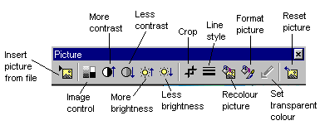You can use the tools on the Picture toolbar to enhance the appearance of your images, e.g., change a coloured image to black and white or a watermark.
To display the Picture toolbar:
On the View menu, select Toolbars.
Click on Picture.

Borders
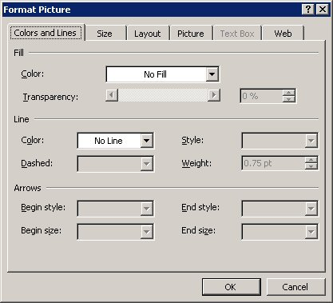
You can place a border around your image in the Format Picture dialog box.
Select the image you want to place a border around.
- On the Format menu, select Picture.
- Select the Colors and Lines tab.
- In the Lines section of the dialog box, select your choice of Color, Style, Dashed (if required), and Weight (thickness).
- Click OK.

Word Art
WordArt enables you to apply special formatting to text.

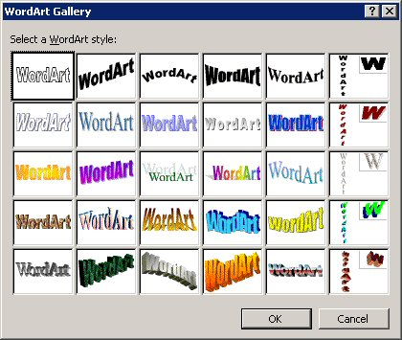
Inserting WordArt
- On the Insert menu, select Picture, then select WordArt from the submenu/ Click the Insert WordArt button on the Drawing toolbar.
- The WordArt Gallery is then displayed.
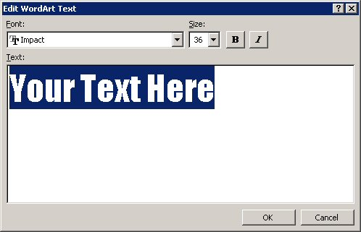
- Select the style you want to use and click OK.
- Select your choice of font in the Font box.
- Select the point size you require in the Size box.
- Click the Bold and/or Italics buttons if required.
- Key in the text you want displayed in the Text area.
- Click OK.

WordArt toolbar
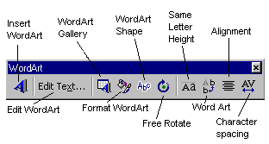Once the text has been inserted onto your slide, the WordArt toolbar appears on your screen.
Use these buttons to further format your text.
To display the WordArt toolbar manually:
On the View menu, select Toolbars, then WordArt.

Inserting Objects

Working with Objects
Most objects (pictures, drawings, charts, imported spreadsheets, etc.) in a document can be moved, copied, aligned, rotated, stacked, grouped and ungrouped.


Selecting objects
Objects can be selected by clicking on them. To select more than one object at a time, hold the Shift key down whilst you click on them/ Use the select tool (the white arrow on the drawing toolbar) to draw a box around all the objects you want to select.

Stacking objects
Objects can be thought of as pieces of overlaying paper. Objects sometimes overlap, covering important information. The order of objects on a page can be changed easily.
To change the order of objects:
- Select the object and then click on the Draw menu on the Drawing toolbar/ right-click on the object to display the shortcut menu.
- Select Order.
- Select either Bring to Front, Send to Back, Bring Forward, or Send Backward.

Rotating or flipping objects
You can rotate an object 90 degrees to the left or right or to any other angle. You can also flip an object horizontally or vertically. You can flip or rotate one object, a set of objects, or a group of objects. If you rotate or flip an AutoShape that has attached text, the text does not rotates or flip with the shape.
Note:
Some pictures, graphs, and organizational charts that you import can't be rotated or flipped because they were not created in Microsoft Office. If you can ungroup an imported object and then regroup its components, you might be able to flip or rotate it. You will not be able to flip or rotate bitmap images.

To rotate or flip an object:
- Select the object you want to rotate.
- On the Draw menu on the Drawing toolbar, select Rotate or flip, then click Free Rotate or select Rotate Left 90°, Rotate Right 90°, Flip Horizontal, or Flip Vertical.
- If you have selected Free Rotate, green handles appear on your object. Click on a handle and drag a corner of the object in the direction you want to rotate it.
Click outside the object to set the rotation.
Helpful hints:
To constrain the rotation of the object to 15-degree angles, hold down the Shift key while you use the Free Rotate tool.
To rotate the object around the handle opposite the handle you're using, click Ctrl while you use the Free Rotate tool.

Grouping and ungrouping objects
When you group objects, you combine them so you can work with them as though they were a single object. You can flip, rotate, and resize or scale all objects in a group as a single unit. You can also change the attributes of all objects in a group at one time. For example, you might change the fill colour or add a shadow to all objects in the group. You can also create groups within groups to help you build complex drawings.
You can ungroup a group of objects at any time, and you can easily regroup them by selecting any one of the objects that was previously grouped.

Grouping objects
- Select the objects you want to group.
- On the Drawing toolbar, click the Draw menu, and then click Group.

Ungrouping objects
- Select the group you want to ungroup.
- On the Drawing toolbar, click the Draw menu, and then click Ungroup.

Regroup objects
- Select any one of the objects that was previously grouped.
- On the Drawing toolbar, click the Draw menu, and then click Regroup.

Align and arrange objects
Word allows you to align and arrange floating drawing objects, but these features do not work with inline drawing objects.
You can align drawing objects relative to each other, to a drawing canvas, or to the page.
There are several ways to align objects.
- You can align them with other objects, such as when you align the sides, middles, or top or bottom edges of objects.
- You can align them in relation to the drawing canvas or page, e.g., at the top or left edge of the canvas/page.
- You can also align objects by using a grid to align them visually, or by using the grid to align them with a corner on the grid as you draw or move the objects.
- You can arrange (or distribute) objects so they are equal distances from each other, either vertically or horizontally, or in relation to the drawing canvas or page.

Aligning objects with other objects
- To align by their left, right, top or bottom edges, select the objects you want to align.
- On the Drawing toolbar, click the Draw menu.
- Point to Align or Distribute.
- Make sure that Relative to Page or Relative to Canvas is NOT selected.
- Click Align Left, Align Right, Align Top, or Align Bottom.

To align objects horizontally by their centres:
- Select the objects you want to align.
- On the Drawing toolbar, click the Draw menu.
- Point to Align or Distribute.
- Make sure that Relative to Page or Relative to Canvas is NOT selected.
Click Align Centre.

To align objects vertically by their middles:
- Select the objects you want to align.
- On the Drawing toolbar, click the Draw menu.
- Point to Align or Distribute.
- Ensure that Relative to Page or Relative to Canvas is NOT selected.
- Click Align Middle.

Align objects in relation to the canvas
- Select the objects you want to align.
- On the Drawing toolbar, click the Draw menu.
- Point to Align or Distribute.
- If Relative to Canvas is selected, click the alignment option you want.
If Relative to Canvas isn't selected, click it, click the Draw menu again, point to Align or Distribute, and then click the option you want.

Align objects in relation to the page
To use this procedure, the objects cannot be on a drawing canvas, and you must be working in print layout view.
- Select the objects you want to align.
- On the Drawing toolbar, click the Draw menu.
- Point to Align or Distribute.
- If Relative to Page is selected, click the alignment option you want.
If Relative to Page isn't selected, click it, click the Draw menu again, point to Align or Distribute, and then click the option you want.

Arrange drawing objects equal distances from each other
Unless you arrange the objects in relation to the page or drawing canvas, you must select three or more objects.

To distribute floating objects equal distances from each other:
- Select the floating drawing objects you want to arrange.
- On the Drawing toolbar, click Draw.
- Point to Align or Distribute, and make sure that Relative to Canvas or Relative to Page is NOT selected.
- Click Distribute Horizontally or Distribute Vertically.
To arrange floating objects equal distances from each other in relation to the drawing canvas:
- Select the floating drawing objects you want to arrange.
- On the Drawing toolbar, click Draw.
- Point to Align or Distribute, and then click Relative to Canvas.
- Click Draw again, point to Align or Distribute, and then click Distribute Horizontally or Distribute Vertically.
To arrange two or more floating objects or drawing canvases relative to the page:
To use this procedure, the objects cannot be on a drawing canvas, and you must be working in print layout view.
- Select the floating drawing objects you want to arrange.
- On the Drawing toolbar, click Draw.
- Point to Align or Distribute, and then click Relative to Page.
- Click Draw again, point to Align or Distribute, and then click Distribute Horizontally or Distribute Vertically.

